**INDEX**

# Table of Contents

**ABSTRACT ACKNOWLEDGEMENT INDEX**

**LIST OF FIGURES**

1. **INTRODUCTION**
2. **ARCHITECTURAL OVERVIEWS**
   1. **Block diagram**
   2. **Working**
   3. **Results**
3. **PROPOSED METHODS**
   1. **Sensor**
      1. **Soil moisture Sensor**
      2. **Temperature Sensor**
   2. **Relay**
   3. **Voltage Regulator**
   4. **Rectifier**
   5. **Arduino UNO**
   6. **GSM Module**
4. **LITERATURE SURVEY**
5. **ADVANTAGES, DISADVANTAGES AND FEATURES**
   1. **Advantages**
      1. Saves time
      2. Saves Money
      3. Saves Water
      4. Improves Growth
      5. Weed Reduction
   2. **Disadvantages**
   3. **Features of irrigation system**
6. **TYPES AND METHOD IRRIGATION**
   1. **Types of Irrigation**
      1. Surface Irrigation
      2. Localized Irrigation
      3. Sprinkler Irrigation
      4. Centre Pivot Irrigation
      5. Sub Irrigation
      6. Manual Irrigation
      7. Drip Irrigation
   2. **Importance of Irrigation**
   3. **Methods of Irrigation**
      1. Traditional Methods of Irrigation
      2. Modern Methods of Irrigation
         1. Sprinkler Irrigation

6.1.2.2 Drip Irrigation

1. **FLOWCHART AND ALGORITHM**
   1. Flowchart for Irrigation
   2. Algorithm for Irrigation
2. **CONCLUSIONS**
3. **REFERENCE**

# List of Figures

**Table of Contents**

* 1. Irrigation System 5
  2. Graph for Irrigation6

2.1 Functional Block Diagram8

2.3 Diagrammatic Results10

* 1. Soil Moisture Sensor 11
  2. Temperature Sensor12
  3. Relay13
  4. Voltage Regulator 13
  5. Filter Circuit of Rectifier14
  6. Arduino14
  7. Gsm15
  8. Surface Irrigation 21
  9. Sprinkler Irrigation 22
  10. Drip Irrigation 23

7.1 Flowchart for Irrigation 25

## Chapter 1 INTRODUCTION

As the world population increases there is an increasing demand of food production because of which agriculture became vital. In the area of agriculture, using an efficient method of irrigation is important. The conventional method of irrigation i.e., the manual method is cumbersome as there is a lack of labour and there is a high possibility of over watering. Designing a system capable of fully automating the irrigation process helps in reduction of human intervention and water wastage. The entire automation process includes a sensing module which is interfaced with a microcontroller from Atmega328p family and also a GSM module. Atmega328p is chosen because of its high reliability and cost effectiveness. The sensing module comprises of a soil moisture sensor and a temperature sensor from which the output is fed to micro controller and this in turn drives a relay for the operation of water pump.

An LCD display is used that displays the values of temperature of surroundings and moisture level of soil and also the status of the motor. As an enhancement to the whole setup a GSM module is also integrated so that the concerned person can be updated with regular notifications about the field status on a registered number

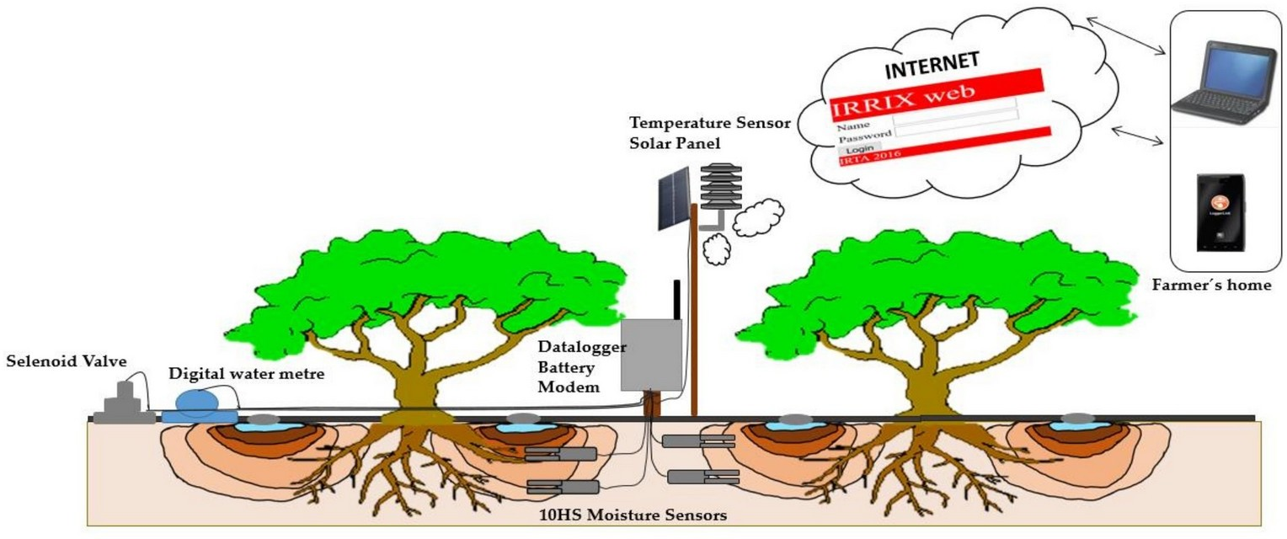

**Fig 1.1: Irrigation System**

The continuous increasing of food demand requires the improvement in food production technology. The food production requires continues monitoring of crops for irrigation with the help of humans. This continuous monitoring by humans is not possible for all the time. Hence automatic irrigation system is a suitable one which helps to irrigate the crops without the help of human intervention. This system will have continuous monitoring that helps better production.

Automatic irrigation system is a new model developed using advancement in communication technology. This system will monitor the soil moisture and environment temperature using wireless sensor networks. The sensed information are send to a centralized computing server for making computation and to report the need of irrigation based on the values received from the sensors. The WSN is integrated with the microcontroller for regulating the functionality of the motor pumps which are part of the system.

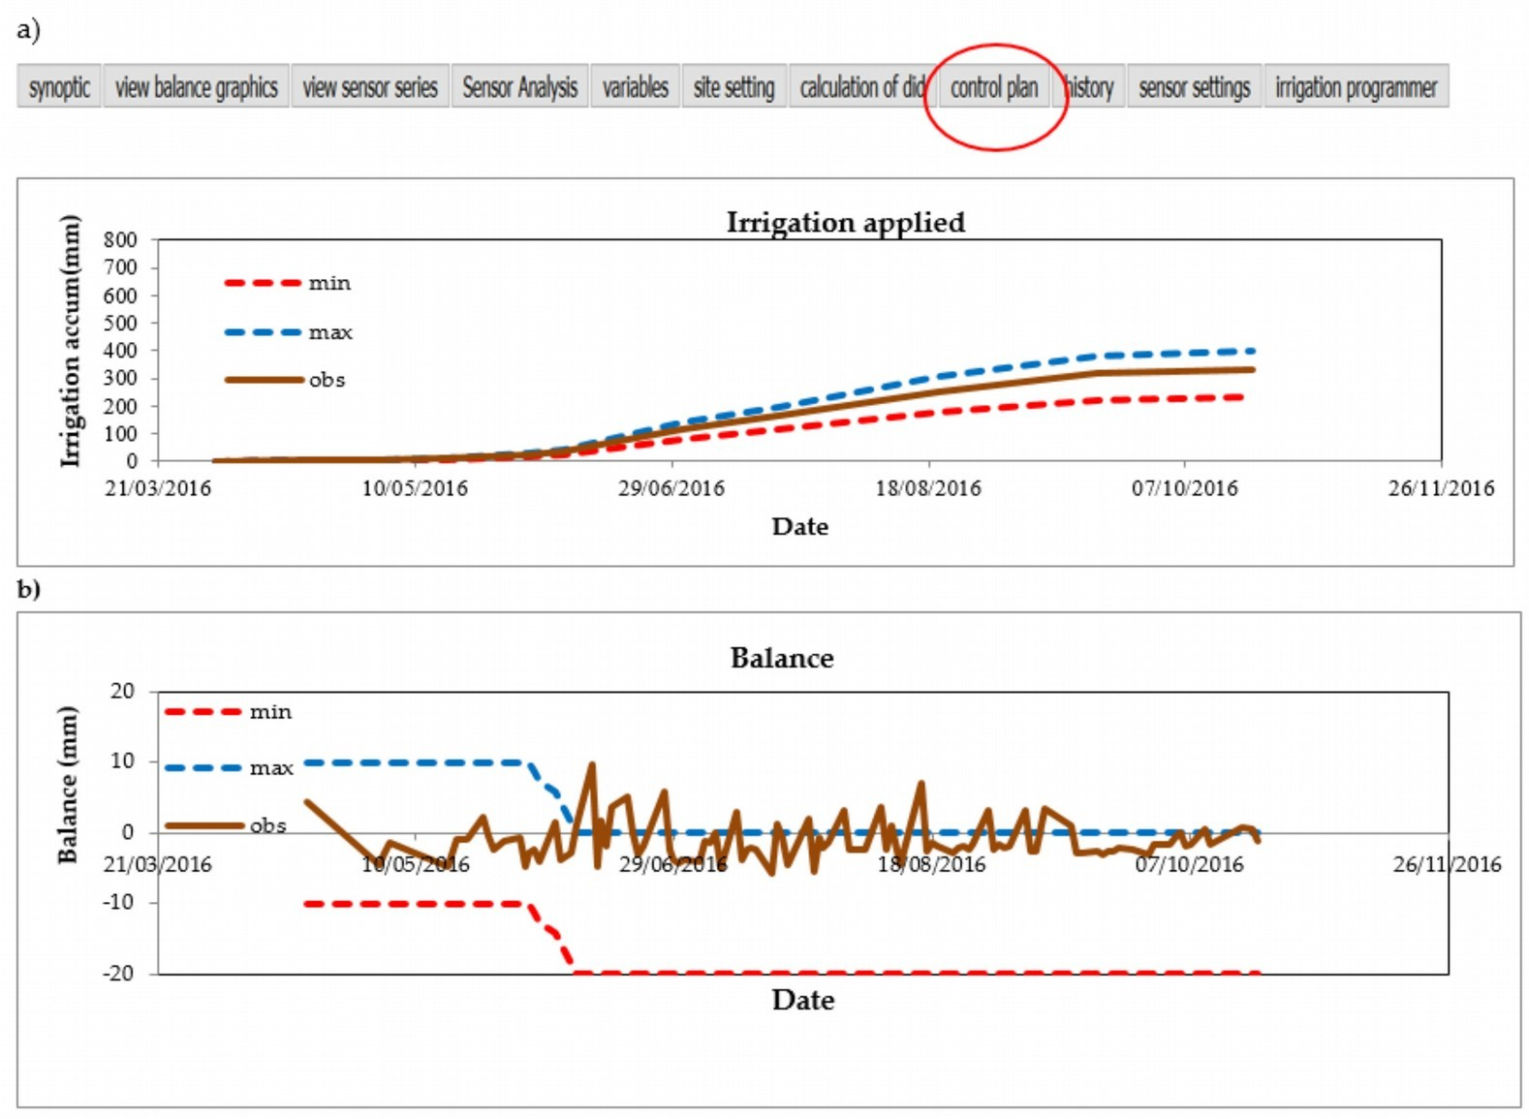

**Fig 1.2: Graph for Irrigation**

The most commonly used soil moisture tester and temperature sensor dht11 is employed for sensing the data from the field. The most popularly used microcontroller Node MCU is used for processing the sensed information and regulating the water pipe. The Node MCU is constructed with ESP8266 chip which is developed with Wi-Fi and Bluetooth. The Node MCU is very inexpensive and it is very easy to work with Arduino IDE. The Arduino IDE works by installing the ESP8266 board manager. To have a good system for irrigation; it can be updated with various technologies. In this seminar, we have discussed several methods for the maintenance and better irrigation of crops.

This ensures constant and proper supervision even in the absence of the person. Since the motor is operated using relay and the relay gets commands from microcontroller which operates according to the temperature and moisture values, water wastage can be seen less since motor gets off automatically.

## Chapter 2

**ARCHITECTURAL OVERVIEW**

## Block Diagram

**Fig. 2.1 Functional Block Diagram**

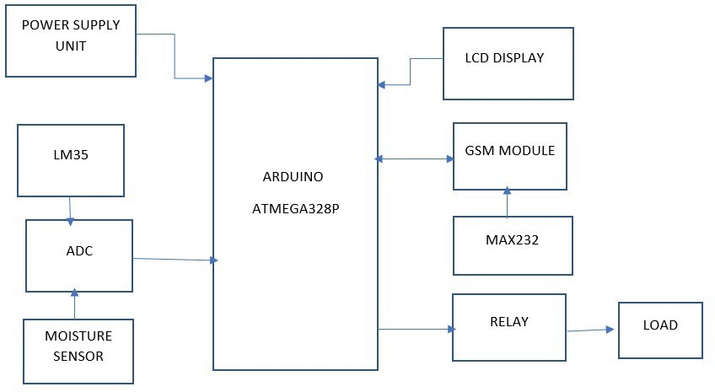

## working:

The Automatic Irrigation System designed with the Wireless Sensor Network and Mobile communication. The WSN consists of sensors which are employed in the agricultural field for sensing the moisture and temperature of the soil. The sensed data are bringing under the microcontroller for regulating the valve of the pump. If the moisture of the soil gets decreased, the sensor sends the data to the microcontroller. Then the microcontroller instructs the valve to turn on. After reaching the threshold value of the moisture, the microcontroller instructs the valve to turn off. The updated value of the moisture and temperature and the action taken by the microcontroller will be send to the user.

A block diagram reveals in which scenario the automation irrigation system works. The moisture and temperature sensors are employed in the agricultural field for sensing the level of moisture and temperature of the soil. The sensors are integrated with the single chipped

microcontroller which is used to calculate and process the data from the sensor. The sensed information is sent to the microcontroller in the form of digital signals. The microcontroller processes the digitalized data and takes relevant actions to regulating the water pump. If the processed data of the soil moisture is low, the motor is indicated by the microcontroller to turn on the water pump.



Pipe



User



**WSN**

Moisture Sensor

Temperature Sensor

Field

Micro Controller

## Results:

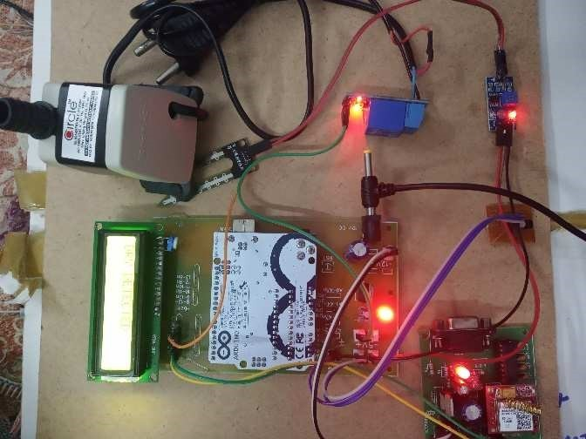

**2.3: Diagrammatic Result**

## Chapter 3

**PROPOSED METHOD**

This seminar proposes a solar photovoltaic (SPV) water pumping system integrated with main supply (grid connected) with an intelligent power sharing concept. In this project, we are using solar panel, Arduino UNO microcontroller, battery and a water motor. Here automatic switching between solar panel and mains supply will be done. When solar power stored in battery becomes zero or low voltage as required, then load will automatically switch to the mains supply.

* 1. **Sensor**

The sensor is electronic equipment employed to identify and react to the natural phenomena and takes it as their input. The input such as moisture, pressure, temperature, heat and light. The signals are generated as the output of the signal which is in the form of human-readable format to the specified location is transmitted through a network for further analysis or processing. In this seminar the two sensors are used majorly for sensing which are listed below.

* + 1. 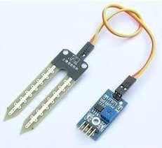Soil Moisture Sensor

**Fig 3.1: soil moisture sensor**

The Soil Moisture Sensor is used to measure the volumetric water content of soil. This makes it ideal for performing experiments in courses such as soil science, agricultural science, environmental science, horticulture, botany, and biology. Use the Soil Moisture Sensor to:

* + - * • Measure the loss of moisture over time due to evaporation and plant uptake.
      * • Evaluate optimum soil moisture contents for various species of plants.
      * • Monitor soil moisture content to control irrigation in greenhouses.
      * • Enhance your Bottle Biology experiments.

The Soil Moisture Sensor uses capacitance to measure dielectric permittivity of the surrounding medium. In soil, dielectric permittivity is a function of the water content. The sensor creates a voltage proportional to the dielectric permittivity, and therefore the water content of the soil.

* + 1. **Temperature Sensor**:

Temperature sensor senses the temperature from the various range of physical body. It is one of the main things had often calculated. The sensing of the temperature using temperature sensor is done by two ways either by direct or indirect method. The direct method is done by made a contact with the source and the indirect method is done without contacting the source body instead of that using radiated energy of the source. In this project, we are using DHT11 which is the temperature sensor.

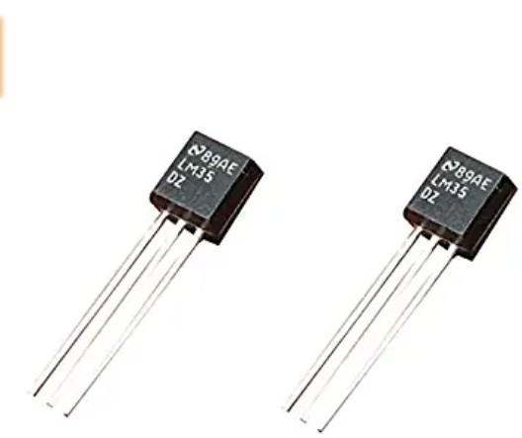

**Fig 3.2: Temperature Sensor**

It consists of four pins, the first pins are used for the voltage supply, the second pin is used as the output pin, the third pin is considered as NULL pin and the last pin is used for the ground supply.

##### Relay:

**Fig 3.3: Relay**

These are neutral relays and picked up for AC current through their coil. These are very fast in action and used on power circuits of the point motors, where high current flows through the contacts. A normal relay would be slow and make sparks which in turn may weld the contacts together.

All relays have two operating values (voltages), one pick-up and the other drop away. The pick- up value is higher than the drop away value.

* 1. **Voltage Regulator:**

A Voltage regulator is a device which converts varying input voltage into a constant regulated output voltage. Voltage regulator can be of two types • Linear Voltage Regulator • Switching Regulators.

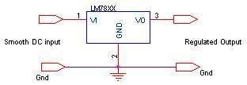

**Fig. 3.4: Voltage Regulator**

##### Rectifier

A rectifier is a device that converts an AC signal into DC signal. For rectification purpose we use a diode, a diode is a device that allows current to pass only in one direction i.e., when the anode of the diode is positive with respect to the cathode also called as forward biased condition & blocks current in the reversed biased condition. Rectifier can be classified as follows:

* Half Wave rectifier.
* Full wave rectifier.
* Bridge Rectifier. *E. Filter*

Even though half wave & full wave rectifier give DC output, none of them provides a constant output voltage. For this we require to smoothen the waveform received from the rectifier. This can be done by using a capacitor at the output of the rectifier this capacitor is also called as “FILTER CAPACITOR”.

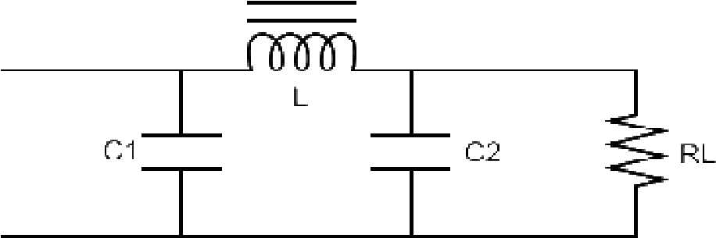

**Fig 3.5: Filter Circuit of Rectifier**

* 1. **The Arduino Uno:**

It is a microcontroller-based board connected to the power supply.

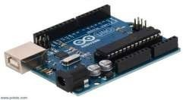

**Fig 3.6 Arduino Uno**

***Arduino Uno*** is a microcontroller board based on the ATmega328P (datasheet). It has 14 digital input/output pins (of which 6 can be used as PWM outputs), 6 analog inputs, a 16 MHz ceramic resonator (CSTCE16M0V53-R0), a USB connection, a power jack, an ICSP header and a reset button.

* 1. **GSM Module:**

It is used to send and store messages. It also alerts the user of any specific data. It is handy and can be carried anywhere easily.

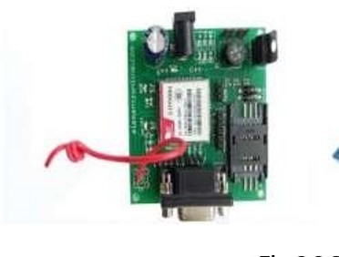

**Fig. 3.7 GSM module**

## Chapter 4

**LITERATURE SURVEY**

In this chapter, we have discussed various types of Automatic Irrigation mechanism for better irrigation. Let us discuss each and every technique of Automatic Irrigation System. Irrigation Management System Using Soil Moisture Sensor and Arduino, SP. Maniraj et al., proposed that the automated irrigation system is done by soil moisture sensor and Arduino. In this system, the control is used to on and off the motor without the help of humans which is done by microcontroller. The LED is provided for the indication of working of the Arduino. The moisture level of the soil will be checked and the irrigation status will be sent to the local host or server.

Automated Irrigation System Using a Wireless Sensor Network and GPRS Module, Joaquín Gutiérrez et al., proposed an automatic irrigation system was introduced to help farmers. In this a wireless network of soil moisture and temperature sensor are employed to senses the information. The gateway unit initiate the actuators and transmits the data which is between the web application and the farmer for the irrigation schedule. The photovoltaic panels are used for the power supply of the system. Development of Software for the Microcontroller Based Automated Drip Irrigation System Using Soil Moisture Sensor, N.V. Gowtham Deekshithulu et al., proposed the design of irrigation system based on the soil moisture sensor and microcontroller to help the farmers to irrigate the lands with right amount of water. Keil vision 3 software is employed with 8051 microcontroller and sensor. When the land reaches the 70% of moisture the pump will turn off and for below 70% the pump will turn on till it reaches particular level of moisture. The regulating of water pump is done with solenoid valve.

Shiraz Pasha B.R., Dr. B Yogesh (2014) The International Journal of Engineering and Science (IJES) developed the Microcontroller Based.

Automated Irrigation System to irrigate the land with the automation technique. The moisture sensor is inserted into the soil. The sensor senses the information and sends the data to the microcontroller. The controller indicates the relay to turn ON the pump if the moisture is below the threshold value and the pump will turn OFF automatically after the moisture level is sensed from the sensor. It will be displayed in the LCD of the controller. S. R. Kumbhar, Arjun P. Ghatule (2013) International Multi Conference of Engineers and Computer Scientists developed the Microcontroller based Controlled Irrigation System for Plantation for irrigating the lands without the manual support. It was developed with the humidity sensor and the

microcontroller. If the set-point value of the humidity sensor goes low the microcontroller turn on the motor to supply the water, after reaching the set-point value then the motor will turn OFF. Karan Kansara (2015) proposed Sensor based Automated Irrigation System with IOT for the welfare

of farmers in the field of irrigation. The connection of the microcontroller from the android app and to the GSM is done by GSM and MAX232 respectively. The moisture level becomes low, the microcontroller initiates the mobile to activate the buzzer for the opening and closing of the valve. Pavithra D. S, M. S. Srinath (2014) proposed GSM based Automatic Irrigation Control System for Efficient Use of Resources and Crop Planning by Using an Android Mobile in which the low moisture content of the soil will be deducted. The moisture data will be sent to the microcontroller. The microcontroller calls the mobile to press the button after hearing the buzzer indication. After that the valve is opened for the supply of water, and then it will attain the certain level of moisture content the sensor updates the moisture level, and the valve will be closed by the signal of the microcontroller. MR. Jagadish (2018) International Journal of Creative Research Thoughts (IJCRT) Wireless Sensor Network Based Agricultural Monitoring System proposed to monitor the field with the help of sensors such as moisture, temperature, pH and water level. The data from those sensors will be transmitted to the Arduino with the help of Zigbee technology. The data also processed in the Raspberry pi for regulating the water pump. The live status of the field will send over the webpage which is obtained from IP address which is pre-defined in the module. Indu Gautam and S.R.N. Reddy (2012) International Journal of Computer Applications proposed an Innovative GSM-Bluetooth based remote controlled embedded system for irrigation which predefines the irrigation time according to the sensor’s data and also depend of crop type for the automation of the system. The system interacts with the user via the SMS. The GSM technology is employed for the message transformation. The SMS charging will be avoided by the use of Bluetooth technology within the particular meters.

Purnima, S.R.N. Reddy (2012) International journal of computer Applications proposed Design of Remote Monitoring and Control System with Automatic Irrigation System using GSM-Bluetooth for remote controlling and monitoring of the irrigation with low cost and less power consumption. The system is designed with sensor and the microcontroller which is interfaced with the Bluetooth for the data transformation within the short range of place for eliminating the charging of the SMS. The GSM technology is employed for the sending of data such as CO2 concentration, low moisture level and the high temperature via the SMS to the farmer.

## Chapter 5

**ADVANTAGES, DISADVANTAGES AND FEATURES**

## Advantages:

##### Saves Time

A programmed water system framework will spare you a lot of time that you in the past would have spent watering your yards, gardens and blooms. You would now be able to have your clocks set, with the goal that watering will occur at the occasions that best suits your scene and the atmosphere where you live. You can go on that occasion realizing that your gardens and blossoms will be kept up and prospering when you return.

##### Saves Money

With a programmed water system framework there is no cash or water squandered, for everything is coordinated, modified and these frameworks all have rain sensors, so every drop of water is utilized just when it is required.

##### Saves Water

Whatever sort of water system framework you introduce, there will be a more prominent saving money on water. You can enable preserve to water with programmed frameworks, for there is no squandering of water, each drop is utilized not squandered away. You can spare somewhere in the range of 30 and 50 percent of the water that you would ordinarily use with other more customary watering strategies.

##### Improves Growth

Whenever plants, yields, yards, or blossoms are watered with littler measures of water over a more drawn-out timeframe, they become quicker, for it is the perfect condition for development. You will appreciate greener and more delicious greenhouses and gardens

##### Weed Reduction

You will notice a reduction in the number of weeds appearing, this is due to the fact that those areas that need water are the only areas receiving water, with the implementation of a specifically designed irrigation system

## Disadvantages:

1. Major disadvantage is time delay.
2. Initial and maintenance cost will be high.
3. Efficiency and Reliability is less.

### Features of Smart Irrigation System

###### This smart irrigation system fulfils all the criteria of an ideal irrigation system. Some of the profitable features are:

* + 1. This smart irrigation system easily adapts with the weather condition and sense the moisture accordingly to operate the water pump

###### The soil moisture sensor easily senses the high-water flow by sensing the moisture present in soil and therefore shuts down and starts automatically

* + 1. Using the smart irrigation system, you can manage the water flow remotely without going to the field
    2. The LCD connected with the circuit displays the soil moisture data regularly which can be used to keep record of moisture at different instances

## Chapter 6

### Types of Irrigation:

There are different types of irrigation practised for improving crop yield. These types of irrigation systems are practised based on the different types of soils, climates, crops and resources. The main types of irrigation followed by farmers include:

###### Surface Irrigation

In this system, no irrigation pump is involved. Here, water is distributed across the land by

gravity.

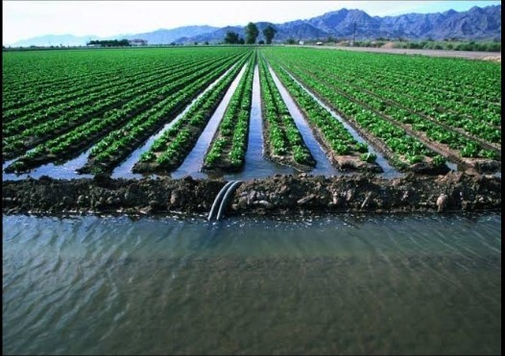

**Fig 6.1: surface irrigation**

###### Localized Irrigation

In this system, water is applied to each plant through a network of pipes under low pressure.

###### Sprinkler Irrigation

Water is distributed from a central location by overhead high-pressure sprinklers or from sprinklers from the moving platform.

In this type, drops of water are delivered near the roots of the plants. This type of irrigation is rarely used as it requires more maintenance.

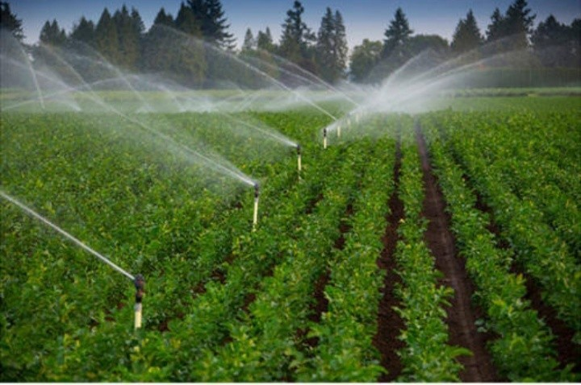

**Fig 6.2: Sprinkler irrigation**

A sprinkler system, as its name suggests, sprinkles water over the crop and helps in an even distribution of water. This method is much advisable in areas facing water scarcity.

Here a pump is connected to pipes which generate pressure and water is sprinkled through nozzles of pipes.

###### Centre Pivot Irrigation

In this, the water is distributed by a sprinkler system moving in a circular pattern.

###### Sub Irrigation

Water is distributed through a system of pumping stations gates, ditches and canals by raising the water table.

###### Manual Irrigation

This a labour intensive and time-consuming system of irrigation. Here, the water is distributed through watering cans by manual labour*.*

* + 1. **Drip System**

In the drip system, water supply is done drop by drop exactly at roots using a hose or pipe. This method can also be used in regions where water availability is less.

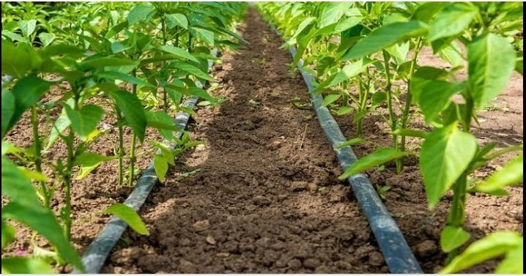

**Fig 6.2: Drip System**

### Importance of Irrigation:

The importance of irrigation can be explained in the following points:

* + 1. Insufficient and uncertain rainfall adversely affects agriculture. Droughts and famines are caused due to low rainfall. Irrigation helps to increase productivity even in low rainfall.
    2. The productivity on irrigated land is higher as compared to the un-irrigated land.
    3. Multiple cropping is not possible in India because the rainy season is specific in most of the regions. However, the climate supports cultivation throughout the year. Irrigation facilities make it possible to grow more than one crop in most of the areas of the country.
    4. Irrigation has helped to bring most of the fallow land under cultivation.
    5. Irrigation has stabilized the output and yield levels.
    6. Irrigation increases the availability of water supply, which in turn increases the income of the farmers.

Irrigation should be optimum because even over-irrigation can spoil the [crop production](https://byjus.com/biology/crop-production/). Excess water leads to waterlogging, hinder germination, increased salt concentration and uprooting because roots can’t withstand standing water. Thus, the proper method is to be used for the best cultivation.

### Methods of Irrigation

Irrigation can be carried out by two different methods:

* + - Traditional Methods
    - Modern Methods

###### Traditional Methods of Irrigation

In this method, irrigation is done manually. Here, a farmer pulls out water from wells or canals by himself or using cattle and carries to farming fields. This method can vary in different regions.

The main advantage of this method is that it is cheap. But its efficiency is poor because of the uneven distribution of water. Also, the chances of water loss are very high.

Some examples of the traditional system are pulley system, lever system, chain pump. Among these, the pump system is the most common and used widely.

###### Modern Methods of Irrigation

The modern method compensates the disadvantages of traditional methods and thus helps in the proper way of water usage.

The modern method involves two systems:

* + - * Sprinkler system
      * Drip system
      1. **Sprinkler System**

A sprinkler system, as its name suggests, sprinkles water over the crop and helps in an even distribution of water. This method is much advisable in areas facing water scarcity.

Here a pump is connected to pipes which generate pressure and water is sprinkled through nozzles of pipes.

* + - 1. **Drip System**

In the drip system, water supply is done drop by drop exactly at roots using a hose or pipe. This method can also be used in regions where water availability is less.

## Chapter 7

**FLOWCHART AND ALGORITHM**

## Flowchart

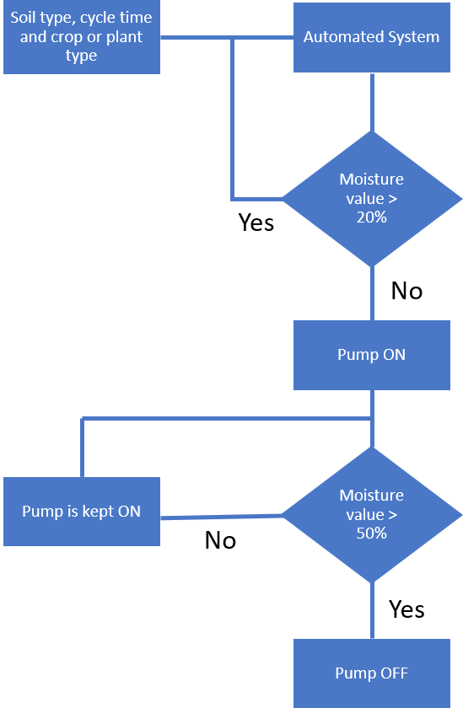

**Fig.7.1: flowchart for irrigation**

**Fig.7.1: flowchart for irrigation**

## Algorithm

**Algorithm for soil moisture sensor**

int Sens1, Sens2; void setup () {

pinMode(A0, INPUT); //Set pin A0 as Sensor 1 pinMode(A1,INPUT); //Set pin A1 as Sensor 2 pinMode(8,OUTPUT); //Set pin 8 as Relay 1 (Pump) pinMode(12,OUTPUT); //Set pin 12 as Relay 2 (Valve 1) pinMode(13,OUTPUT); //Set pin 13 as Relay 3 (Valve 2)

//relays are in NO (normally open) condition Serial.begin(9600);

}

void loop ()

{

Sens1= analogRead(A0); Sens2= analogRead(A1);

Sens1= map (Sens1,1017,0,0,100); //calibration of Sensor

1

Sens2= map (Sens2,1017,0,0,100); //calibration of Sensor

2

if (Sens1<20)

{

digitalWrite(12, LOW); //if soil moisture is less than 20% in section 1, open valve 1 and supply water to section

1

}

else if (Sens1>50 && Sens1<100)

{

digitalWrite(12, HIGH); //if soil moisture is greater than 50% in section 1, close valve 1 and stop water supply

to section 1

}

if (Sens2<20)

{

digitalWrite(13, LOW); //if soil moisture is less than 20% in section 2, open valve 2 and supply water to section

2

}

else if (Sens2>50 && Sens2<100)

{

digitalWrite(13, HIGH); //if soil moisture is greater than 50% in section 2, close valve 2 and stop water supply

to section 2

}

if (Sens1<20 || Sens2<20)

{

digitalWrite(8, LOW); //pump on

}

if (Sens1>50 && Sens2>50)

{

digitalWrite(8, HIGH); //pump off

}

}

**Chapter 8**

# CONCLUSION

The ‘**Automatic Irrigation System using Soil Moisture Sensor’** has been developed and tested successfully and found to function automatically

In this seminar, a new Arduino based system [5] has been implemented to solve the farmer’s problems. The objective function was to notify about the status of motor through SMS. The soil moisture goes below 72% the LCD screen displays the accurate value and the farmer receives a message, “NO MOISTURE AT THE FIELD MOTOR ON”. If adequate amount of moisture is found the farmer receives a message, “MOISTURE DETECTED AT FIELD MOTOR OFF”.

# REFERENCES

###### Network using Ant Lion Optimization algorithm”, International Journal of Applied Engineering Research (IJAER), ISSN:0973-4562, Vol.12, No.12, pp.3084- 3089,July 2017.

1. A. V. Sudhakara Reddy, Dr. M. Damodar Reddy, “Application of Whale Optimization Algorithm for Distribution feeder reconfiguration”, i-manager’s Journal on Electrical Engineering, Vol.11, No.3, pp.17-24, Jan-Mar2012

###### “ Smart Irrigation System using Arduino”- S.G. Manoj Guru, Etal. March 2017

G. Eason, B. Noble, and I.N. Sneddon, “On certain integrals of Lipschitz-Hankel type involving products of

###### “Automatic fault detection in low-cost frequency domain soil moisture sensor”-

M.J. Oates, Etal, 2016 Bessel functions,” Phil. Trans. Roy. Soc. London, vol. A247, pp. 529-551, April 1955. (references)

###### “ Smart Drip Irrigation System using Raspberry pi and Arduino”- Nikhil Agrawal, Etal, 2015 J. Clerk Maxwell, A Treatise on Electricity and Magnetism, 3rd ed., vol. 2. Oxford: Clarendon, 1892, pp.68-73.

1. “ Automated Irrigation System using a Wireless Sensor Network and GPRS Module”- Joaquin Gutierrez, Etal, Volume 63 January 2014

###### “ Micro Controller Based Automatic Plant Irrigation System”- Venkata Naga Rohit Gunturi, Volume 2, Issue 4 April l2013

1. “ Design of Remote Monitoring and Control System with Automatic Irrigation System using GSM-Bluetooth”- Purnima, Etal Volume 42, June 2012

###### “Energy efficient data transmission in automatic irrigation system using wireless sensor network”- M-Nesa Sudha, Etal, 2011Page 215-221